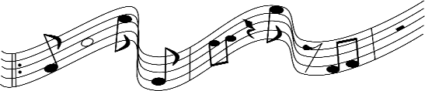Evergreen Park Community High School Music Boosters Association

APPLICATION FOR MUSIC CAMP SCHOLARSHIP
NAME: DATE:
Current involvement in program: Band Choir Guard Other How long have you participated in the music program?
Camp Information:
Location: Date of Camp: Name of Program: Cost:
- Please attach/scan copy of Music camp brochure
Please write a brief statement about why you are interested in attending this music camp (you may use/attach additional paper if necessary.)

Applicants, please complete this form and return it to EPCHSMusicBoosters@gmail.com by midnight Wednesday, April 12, 2023. Once the applications have been received, they will be reviewed by the Scholarship Committee and scholarships will be announced at the Music Booster Meeting on Monday, May 15, 2023.
- Only students whose family are members of the Music Boosters are eligible to apply, membership deadline for scholarship consideration is October 1, 2022.
- All checks are made out directly to the Music Camp.
- Scholarship is available only to current Freshmen, Sophomores and Juniors.

